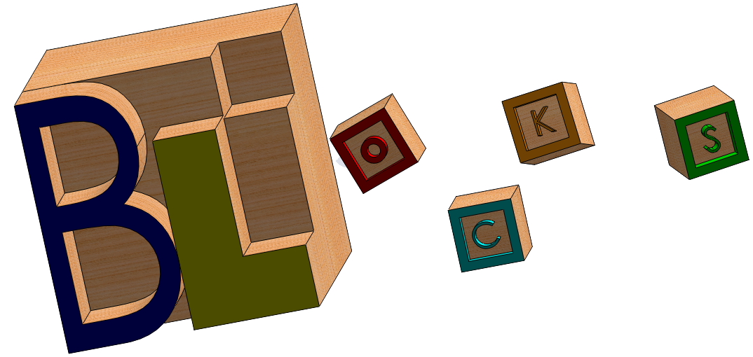

Team Description[1]

Lichen Han – Project Manager and Lead Technology Officer

Lichen is a third-year UC Berkeley undergraduate pursuing a Bachelor of Arts in Computer Science. From a young age, he has identified his passions as art, technology and innovation. Over the course of his academic career, Lichen has always endeavored to bring the best of both worlds together – to merge art with science in creating unique and exciting works whether they are for school projects or for personal fulfillment.

As a computer science major, Lichen possesses strong skills in software engineering and web development. His past work experiences include web and UI design, web development, mobile development – front-end and back end – and mobile architecture. Along with his programming expertise, Lichen has strong writing abilities and course history with entrepreneurship.

Lichen believes that given his penchant for both humanities and sciences, he can bring his understanding of both spheres of knowledge together to culminate in the ultimate business model – one that satisfies consumer demand for a product that is functional, has high market relevance and still *looks* and *works* great. Lichen’s overarching role will be Project Management. He intends to provide dialogue between technical team members, designers and business analysts. He will also be responsible for providing technical specification and features. In doing so, Lichen hopes to make sure that the needs of the business in all three sectors are met in a fluid fashion such that the end result is always competitive, innovative, and aiming at success.

Below is his LinkedIn profile:

<http://www.linkedin.com/pub/lichen-han/52/217/b5>

Gordon Yang – Product Manager and Lead Designer

Gordon is a third-year UC Berkeley mechanical engineering major who wishes to pursue a career in product development. He intends to focus on the design aspect that goes into developing the BLOCKS web service. He enjoys all kinds of design, ranging from graphic design to product design and takes great joy in creating something from his ideas. He is often brimming with new ideas and can easily identify ways to make a product better.

Gordon has a utopian and independent outlook in what happens around him and finds these characteristics as constructive in helping him brainstorm great designs. He is also involved in many student organizations where teamwork is key to success so he understands the merit of collaboration and ways to improve it.

Gordon will serve as the product manager and lead designer of the Blocks team, and will be in charge of managing the product specifications along with the various design features of BLOCKS. In short, Gordon’s role is to ensure the constant improvement in the overall customer experience with the business and the product.

Below is his LinkedIn profile:

<http://www.linkedin.com/pub/gordon-yang/32/931/724/>

1. Full team is not yet finalized